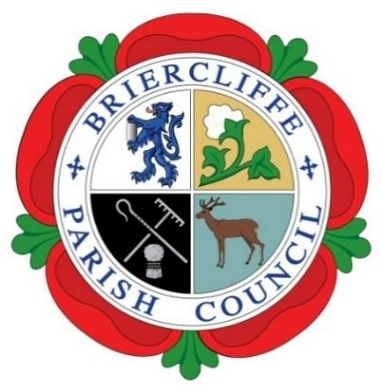
Briercliffe with Extwistle Parish Council

Thursday 13th February 2025 at 7.30pm at Briercliffe Community Centre.

Present: Councillors Michael McFarlane (Chair) Roger Frost, Michael Greenwood, John Marlow, and Libby Lalor

In Attendance: R Greenwood (Temp Clerk)

An Extraordinary meeting of the Parish Council for Financial Resolutions
 | Actions by Clerk | Cllr Support
24/25/0293 Apologies for absence
Apologies were received and accepted from Councillor Gordon Lishman, Pippa Lishman and C Halstead.

24/25/0294 Disclosable Pecuniary Interest
No Councillors declared any pecuniary interest.
24/25/0295 Finance – legal advice
It was resolved to pay the invoice of £480 to Thompson Solicitors for legal advice for the former clerk. Cheque 1987. All in favour
24/25/0296 – holiday pay
It was resolved to pay two cheques for the former clerks holiday pay, cheque 1988 was raised for £378.10. Cheque 1989 was raised to HMRC for PAYE for £94.40.
All in favour.
24/25/0297 – PILON pay
It was resolved to pay three cheques for the form clerks PILON pay. (Pay in lieu of notice) .
Cheque 1990 to Stephen Watson for £1406.84
Cheque 1991 to HMRC for PAYE for £378.00
Cheque 1992 to HMRC for NIC for £105.16
24/25/0298 – Dates of next meeting
- March 6th 2025
- April 3rd 2025
- May 8th 2025 Annual Meeting
- June 6 2025
- July 10 2025
- Aug 7 2025
- Sept 4 2025
- Oct 3 2025
- Nov 6 2025
- Dec 4 2025
- Jan 8 2026
- Feb 5 2026
- Mar 5 2026
- Apr 2 2026
- May 14 2026 (and Annual meeting; first meeting after elections)

The meeting closed at 8pm

